Form 3. Local Activities Standard Operating Procedures
For the following locations: Quafies reserve, Oaks playground, Longhurst fields.

Local Activities Standard Operating Procedures | Version: | 1 | Date: | 8 April 2021 | Next review date: | 8 April 2022

Prior to leaving

In lessons cover:
What to take with us: fleece, jacket, sunhat, food and water
Shoes to wear
How to keep ourselves and others safe
What to do if lost
Why we are going there
What we will be doing there

Check:
Clothing, footwear, food and water check
Weather forecast and decide if appropriate for activity to go ahead
First Aid kit present
Health information and caregiver contact details (checked and taken on trip)
Participant medication packed (where it is and the instructions)
Volunteers approved (procedures completed)

On leaving

Leave Intentions form (including any approved pick-ups from the activity site), at the office in the EOTC box, including updated Student list with attendance recorded.
Sign out in the Trip book and on the Whiteboard.

Major hazards to monitor

- Road crossings – injury
- Temperature – hyperthermia or hypothermia and sunburn
- Wasp/bee stings - allergic reactions
- Medical Emergencies – asthma
- Water – drowning
- Boundaries – lost students

Standard requirements

- Leadership and supervision structure discussed and agreed by all those attending
- Obtain weather forecast and decide if appropriate for activity to go ahead
- Discuss with students on behavioural expectations, walking there and keeping the group together, boundaries, equipment use
- Staff must manage all road crossings
- Monitor students’ well-being, including food and water intake and sunscreen
- Monitor weather
- Set boundaries at the site – paying particular attention to water – minimum of one supervisor at the water.
- Sight and mark off all students every 30 minutes if they are spread across the site
- Sanitise or wash hands before eating
- Supervisor must accompany any students using the public toilets to the toilet block and wait outside
- Check personal medication use when needed
- Roll check completed before leaving the site
- Follow the Emergency Response Guide in the case of an incident or emergency.

Safety Equipment
- First aid kit  - Hand sanitiser | - Emergency Response Guide | - Cell phone

Individual Equipment

- Appropriate shoes  - Polar fleece or woollen jersey | - Raincoat  - Sunscreen  - Sunhat | - Water bottle  - Food

Specific Site Information

Participants
Jane – needs her medication at lunchtime
Bob – needs EpiPen with him

Route
A supervisor must stand at Murphy’s road corner to watch for oncoming traffic before students cross the road

Location
Only one student on the flying fox platform at any one time, no students to attempt to ‘catch’ students at the end of the flying fox

FRONT OF MIND (Hazards on the day)

Bob – allergic to wasp stings

Event Specific Contacts

Volunteer 1 027 744532

Site Map
Quaifes reserve Water
Oak’s playground,
Longhurst fields

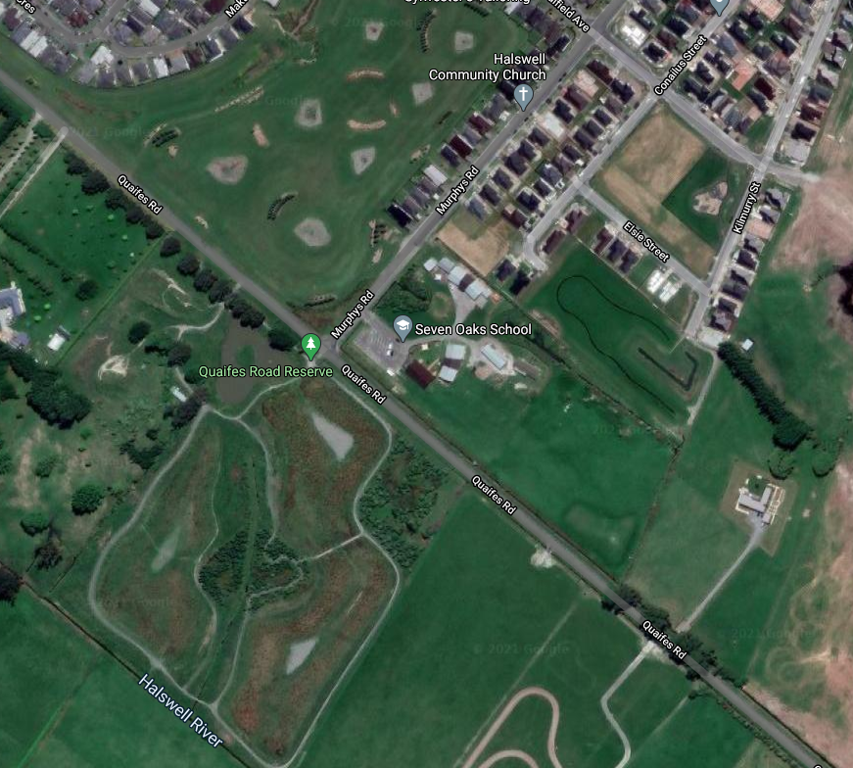

On Return

Complete:

Sign back in in the Trip book and wipe trip off the white board

Complete any incident reporting required

Return First Aid kit, noting any usage

Completed by: |  | Date: |  | Approved: |  | Date:

