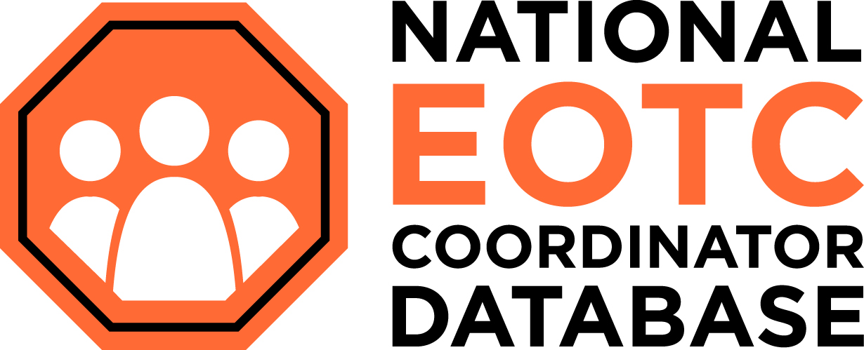

A 2-Day Professional Learning Workshop
2020, Edition 10

This work is licensed under the Creative Commons Attribution-Non- Commercial 4.0 International License. To view a copy of this license, visit http://creativecommons.org/licenses/by-nc/4.0/.

EOTC AND EFFECTIVE safety MANAGEMENT systems for schools
Supporting resources for PLD participants

About EONZ

EONZ is a national-level grassroots organisation supporting educators across the outdoor and education sectors. We are committed to fostering and advocating for safe and quality learning outside the classroom, and in building the capability of teachers and schools to develop and implement quality EOTC programmes for their learners.
Subscribe to open-source EOTC Updates. Access back issues of Te Whakatika, the membership publication. Take out a membership. Find details at www.eonz.org.nz.

Strengthen your voice by strengthening our voice!

Become an EONZ member

Your membership:
- Gives us a mandate to advocate on your behalf – the larger our membership the stronger the voice
- Keeps you up to date with all things EOTC
- Entitles you to membership benefits – discounted rates (PLD programmes & conferences, consultation & support), copies of Te Whakatika and more

Individual membership: $50
Small organisation: schools with a student roll less than 300 $75
Organisation: schools with a student roll greater than 300 $110

The National EOTC Coordinator Database

This key initiative supports schools via the EOTC coordinator and is identified as an element of good practice EOTC Management - see Ministry of Education EOTC Guidelines 2016, Bringing the Curriculum Alive (p59).
Ensure your EOTC coordinator is registered and retains currency on the database. Find out more.
The initiative is not connected to EONZ membership and is FREE to schools, along with direct support for EOTC management through eotcsupport@eonz.org.nz

Overarching Key Messages

- LEARNING AND SAFETY GO HAND IN HAND
- The EOTC Guidelines support national curricula, The New Zealand Curriculum and
Te Marautanga o Aotearoa
- Quality EOTC is designed to meet learner needs
- EOTC consists of all curriculum-based teaching and learning outside the classroom, including sport
- EOTC management systems must be embedded within school-wide approaches to health and safety
- Quality EOTC is underpinned by planning, competent staff, consistent implementation, and review of systems to ensure current good practice
- CONSULT, COORDINATE, COOPERATE with all involved

DAY 1

Key Messages

Learning

Planning for EOTC experiences should start with identifying student needs and desired learning outcomes

Each EOTC experience should have a purpose that relates to the national curriculum

Consciously identify the best location for each experience

Develop a whole-school approach to learning through EOTC that supports meeting the needs of students

Regular review of teaching and learning programmes to ascertain impact on student learning is critical

People
- Competent staff and clear roles and responsibilities are key to learning safely
- Match staff competence and supervision structures to effectively deliver the activity
- Communication between all parties involved is essential – CONSULT – COOPERATE – COORDINATE
- There are legal requirements which everyone must observe
- Leaders must keep abreast of the relevant good practice and act accordingly

EOTC Management Workshop 1 Notes and Actions
Section/Topic | Notes | Actions (and date for completion) | By/with whom
Intro
EONZ info & support
EOTC database
Overarching key messages
Learning
Why EOTC?

What, when, who?

New approaches

People
Safety – a shared responsibility

Legal considerations

Leader Competence

Effective Supervision

Between Workshop tasks
- Find out about your school wide Health and Safety management system and how EOTC fits.
- Complete as many of the sample audit questions as you can.
- Identify how your school records EOTC incidents and near misses.
- Bring your school’s EOTC Safety Management System to Workshop 2.
- Find your Crisis Management Plan or TIRPS plan and bring to Workshop 2.

Students

Learning needs based on what
student brings, including subject
knowledge, physical abilities, swimming,
health information, personal goals.

Desired learning outcomes

Select Teaching Strategies

Is EOTC the best strategy to meet learning outcomes?

Teaching and
learning

outside the
classroom

Logistics

Includes: consideration of cost.,
school calendar of events, in-
formed parental consent,
transport and assessment
requirements.

Incidents

Incident recording (including
near misses) reported, ana-
lysed and subsequent practice
informed.

Leadership

Competent leaders
allocated and super -
vision structure developed.

Emergency preparedness

Procedures in place and practices for
dealing with emergencies including the
associated trauma, communications and
media releases.

Location

Environment/s and/or venues
selected through a site
visit and/or site register.

Approval

Gained from the person/s the board has
delegated responsibility to, may be the
principal, and/or senior staff and/or the
EOTC Coordinator.

NZ Curriculum & Te Marautanga o Aotearoa

Cultural responsiveness & sustainability

Monitoring & responding
throughout the process

Communication through the process

Evaluation and review throughout process

Including learning programmes, sustainable practices, incidents, and systems.

YES!

Risks

Identified, assessed
for significance and
mitigation strategies
selected.

Learning & Safety go hand in hand

5
Effective Supervision
The following pages are excerpts from an original work by Gemma Periam called Let’s no longer talk ‘ratios’, Out and About, Issue 17, Summer 2006/07 and updated in 2013.
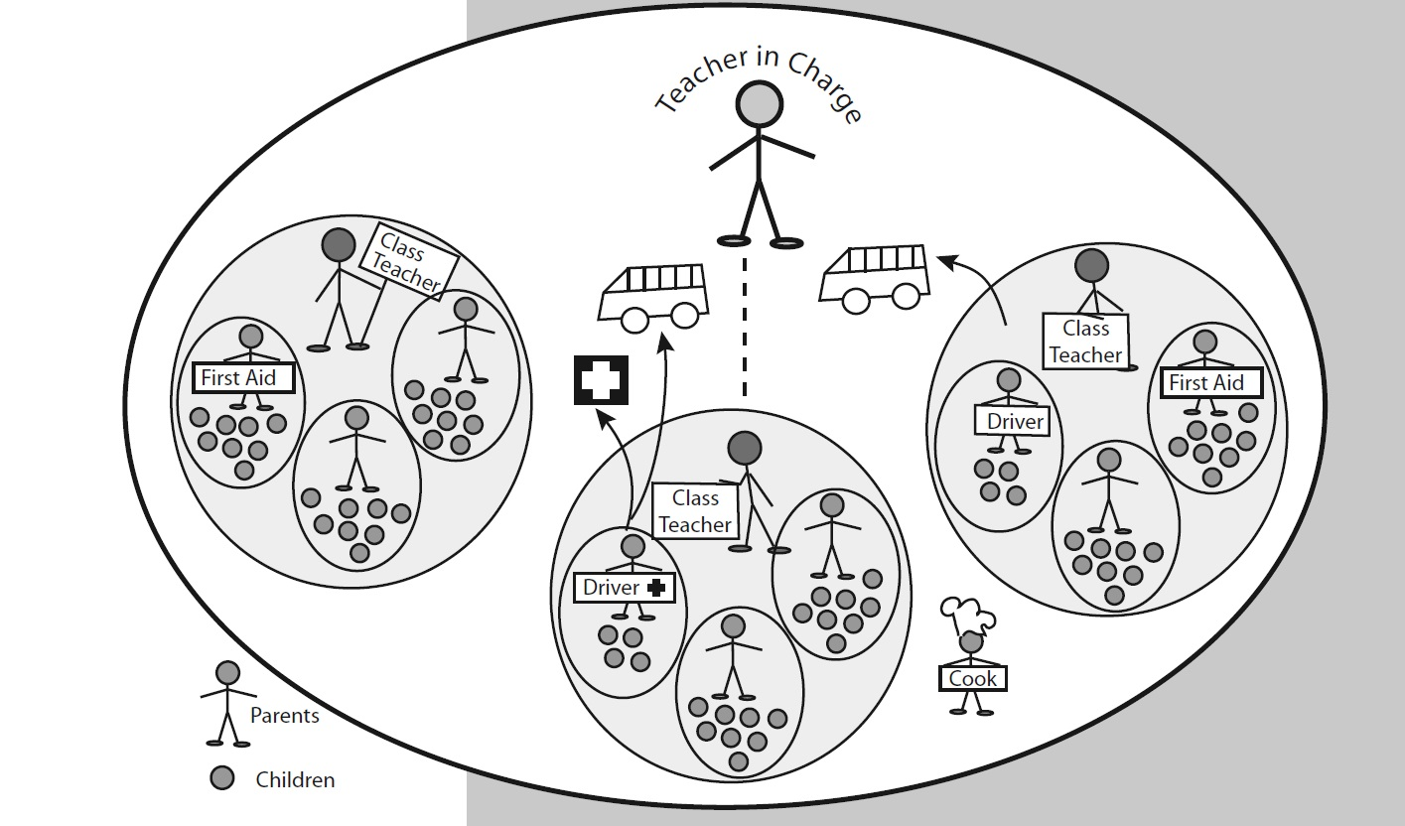
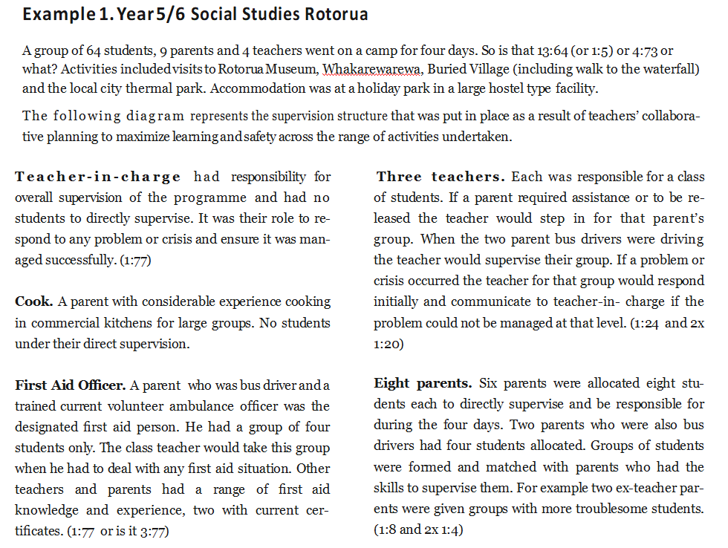
Example 2. Year 10 Day tramp Hunua

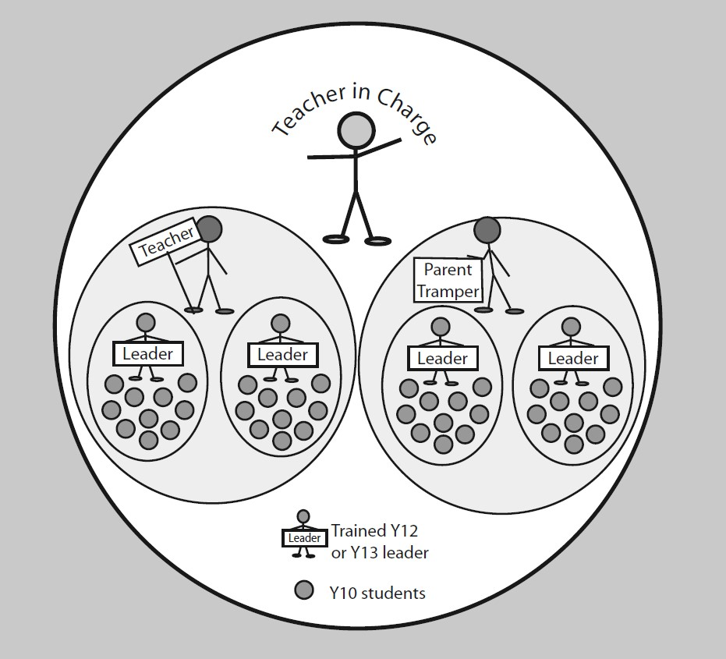
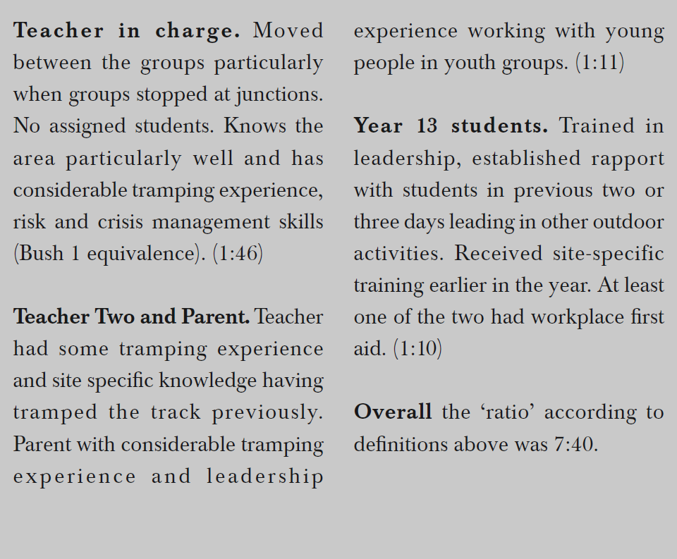
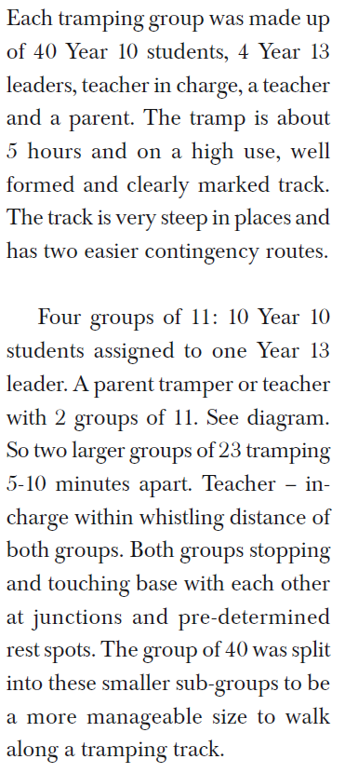
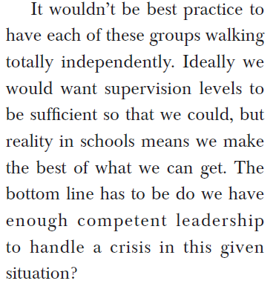

www.eonz.org.nz | Out and About ▲ Issue 28 ▲ Winter 2013

DAY 2

Key Messages

Planning
- There are stages required in the planning of any EOTC event, the extent of paperwork required to document planning should be appropriate to the level of risk
- Health and Safety of EOTC participants is enhanced when risk assessment and management processes focus on ‘significant risk’* and is known by all leaders (* Risks with potential for notifiable injury or illness)
- Roles and Responsibilities for all parties involved should be clearly communicated (Consult-cooperate-coordinate)

Emergency Preparedness
- An emergency plan is essential
- You should practice your emergency plan regularly
- EOTC emergency plans should be part of school wide emergency processes
- Incident recording, reporting, reviewing is important

Strengthening School Processes
- Comparing your school’s processes with those in other schools and with recommended good practices can strengthen your EOTC system
- Ensuring your EOTC safety management system sits under school-wide Health and Safety processes and alongside other safety management systems in your school, strengthens safe behaviour and the school’s safety culture
- Regular review of teaching and learning programmes, staffing (competencies, roles and responsibilities) and planning processes is required to keep up with good practice

EOTC Management Workshop 2 Notes and Actions
Section/Topic | Notes | Actions (and date for completion) | By/with whom
Overarching systems

SM Plan

Event procedures

Comparing and Contrasting Systems  - Proposal and approval  - Paperwork proportional to risk  - Communication internal/external  - Who makes decisions  - Plan and prepare  - Risk assessment current practice  - Good practice guidelines  - External providers  - Implement  - Monitoring & responding  - Emergency response  - Post Event  - Handling incidents  - Event and system review | (consider what you need to keep, what you need to modify/develop and what you need to stop/change)
Strengthening school processes
Shared good ideas

Digital platforms

PLD

Systems Review e.g. audit

Where to from here?  What will you do starting tomorrow?  What support from EONZ will help? |  | Write down two actions you will take ASAP on return to school

Key Resources referred to in this course

Education Outdoors New Zealand www.eonz.org.nz
- National EOTC Coordinator Database registration page
- Resources and links supporting good practice EOTC management
- Responsibilities for Schools concerning the Adventure Activity Regulations

Ministry of Education References:
- EOTC Guidelines 2016, Bringing the Curriculum Alive
- EOTC Safety Management Plan Template
- EOTC SMP Tools Package
- Health and Safety Practical Guide for Boards of Trustees and School Leaders PDF link

Latest EOTC Research
EOTC in Aotearoa New Zealand – A comprehensive national Study: Final Report

Support Adventure - Good Practice Guides for Outdoor Activities:
- Overarching Managing Risk Guidance
- Good Practice Guidelines for Outdoor Activities – General Guidance
- Activity Specific Guides and Planning Templates e.g. overnight camping (scroll down to activities)

Support Adventure - Adventure Activities Guidelines:
- Activity Safety Guidelines (ASGs)
- Sources of written good practice information for adventure activities

Digital System Example
- Green Bay High School (DIY, google based) https://sites.google.com/greenbayhigh.school.nz/gbhs-eotc
- Safety Seek (Commercial)

Systems Safety Audit (EOTC)
- OutdoorsMark EOTC/Outdoor Education Safety Audit Form
- OutdoorsMark EOTC/Outdoor Education Safety Audit Form – Guidance Document

Further Useful Links

Organisations
- Ministry of Education:
- TKI - EOTC Guidelines: Bringing the Curriculum Alive http://eotc.tki.org.nz/EOTC-home/EOTC-Guidelines
- Health and safety guides and tools
- Safety Checking workers and child protection policy for schools and kura
- What checks do I need to undertake for adults coming into my school or kura?

- ERO: Education outside the Classroom: Schools’ Use of EOTC Guidelines (Oct. 2011)
- See Appendix 1: Indicators of Good Practice

- NZ Trustees Association (NZSTA): www.nzsta.org.nz

- Worksafe New Zealand: www.business.govt.nz/worksafe
- Adventure Activities homepage
- Information for schools, education providers and clubs
- Information for contractors and organisations using contractors
- Register of adventure activity operators direct link

- NZ Mountain Safety Council (MSC):
- Outdoor Activity guides / videos / printed resources / Safety tips www.mountainsafety.org.nz
- Adventure Smart https://www.adventuresmart.org.nz/

- New Zealand Walking Access Commission: www.walkingaccess.govt.nz/
- NZ Association for Environmental Education (NZAEE): www.nzaee.org.nz

- Recreation Aotearoa: www.nzrecreation.org.nz/Site/outdoors/

Curriculum
- TKI:
- EOTC Community (MOE): http://eotc.tki.org.nz/EOTC-home
- EOTC activity ideas and tools
- EOTC case studies – EOTC in Action
- Learning Experiences Outside The Classroom (LEOTC): http://eotc.tki.org.nz/LEOTC-home

- Revisioning School Camps – a teaching and learning resource
Qualifications
- Skills Active Aotearoa: www.skillsactive.org.nz
- New Zealand Certificate in Outdoor Leadership

- Ministry of Education subsidies available for practising teachers completing an EOTC qualification.

- New Zealand Register of Recreation Professionals (NZRRP): http://nzrrp.co.nz/
(The NZRRP is not a Worksafe register but it is a tool for schools to utilise when looking for qualified external providers to contract)

- NZ Outdoor Instructors Association (NZOIA): www.nzoia.org.nz

Other Codes of Practice and good practice
- Department of Conservation (DOC)
Codes of practice/access: www.doc.govt.nz/parks-and-recreation/know-before-you-go/care-codes/

- NZ Walking Access Commission
- Outdoor Access Code
- Knowledge base

