Emergency Response Scenario – Zoo Trip (injury)

(Years 5 &6 or Year 9, 2 buses 60 students plus teachers and parent supervisors)
The bus has just pulled into the car park at the zoo. A student spots a friend from another school across the car park, rushes off the bus, runs across the car park to meet their friend, gets hit by a car, and is in too much pain to get up.

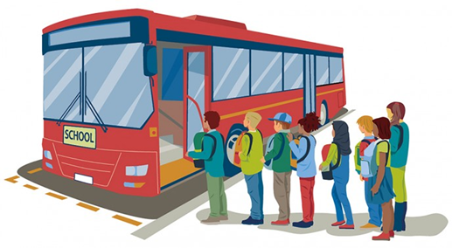

Task
What steps would you take and in what order to manage this? Refer to your school emergency response plans and processes. Be ready to share your learning
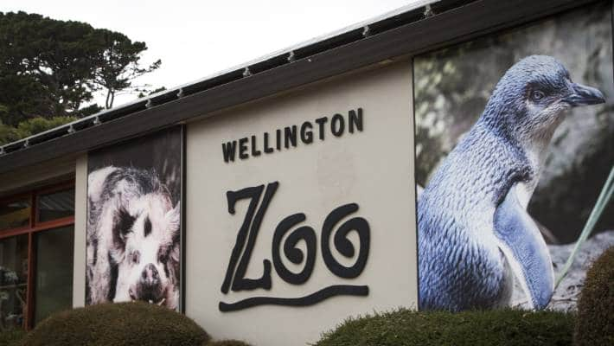

Questions to consider – Emergency response
- What did you do first?
- What roles did you allocate?
- What information did you need?
- What course of action did you take?
- Who did you communicate with? (How and when? How did you deal with cell phones?)
- How did you resolve the situation?
- Did you discuss, debrief, offer support, record, report and review the incident?

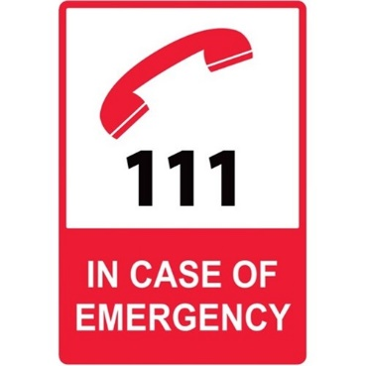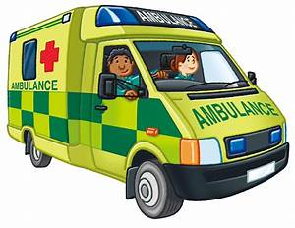

Refer to EOTC Guidelines Tool Kit - Sample Form 14 and 15

